Togo Hunger Story Review

Progress and general stats:
- Prevalence of Undernourishment
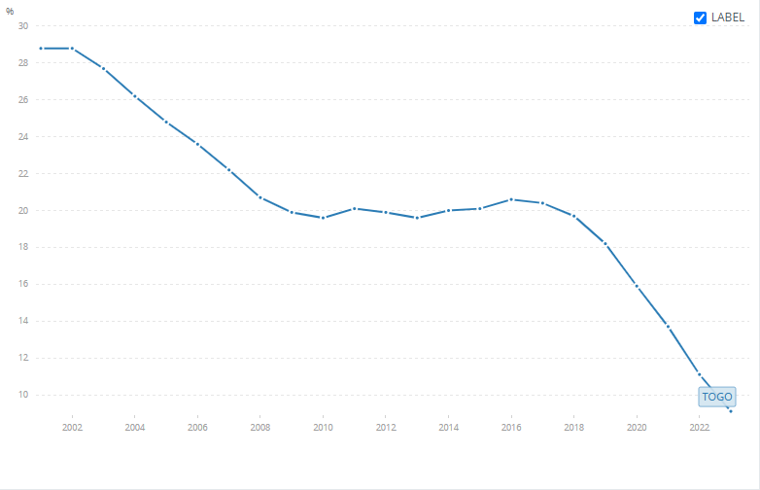
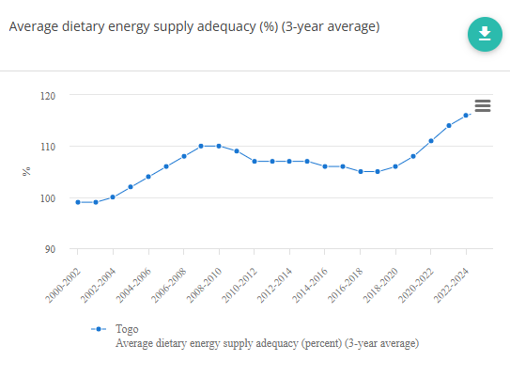(FAO STAT)
- economy heavily depends on commercial and subsistence agriculture, which employs 60 percent of the labor force.” (WFP)
- Competing ILO estimate: currently 38% (Databank)
- “In 2024, Togo recorded a record cereal production of 1.5 million tons, against a backdrop of steady growth since 2019, while poultry numbers topped 38 million, and fish farming rose from just 20 tons in 2011 to 1,300 tons. With UN support, over 15,000 producers and 10,000 vulnerable farming households, more than half led by women, grew their yields through training, digital advisory tools in local languages, and stronger value chains.” (UN DCO)

Agriculture Sector Support Project (PASA)
- “The projects supported the following activities: the marketing of rice and maize and traditional export crops like cotton, coffee, and cocoa; freshwater fish farming by facilitating access to production technologies, training, critical inputs, land security, and financial resources from local banks; and capacity building of the Ministry of Agriculture, Livestock, and Fisheries” (GAFSP)
- 2017: “Rice producers as well as farmers producing soy, cassava, and corn, are participating in the PASA mainly through cooperatives called ESOPs (Entreprises et services d’organisation des producteurs),
  - ESOPs are set up by the project
  - organize producers and help them access inputs (seeds and fertilizers)
  - improve their productivity and the quality of their crops
  - get their crops sold at a better price than they would be able to get on their own.” (WB Blog)
- 2017: ESOPs help them pool their savings to finance the inputs materials, and equipment used to process their crops
  - Also for start-up activities
- 2017: The project does not include infrastructure investments such as irrigation schemes, despite the critical need to improve irrigation (WB Blog)
- Results (GAFSP):
  - rice yields increased by 30 percent
  - enabled 13,979 beneficiaries to become members of an association or cooperative
  - rehabilitation of 17,174 hectares of coffee and 11,578 hectares of cocoa plantations using improved planting material
  - 6,951 tons of freshwater fish production (far exceeding the project target of 2,500 tons)
  - 877,191 people, people benefitted from the project, of whom 13 percent were women
- Paragraph:
  - The Agriculture Sector Support Project (PASA) worked to strengthen marketing for rice, maize, and traditional export crops like cotton, coffee, and cocoa, while also promoting freshwater fish farming and building capacity within the Ministry of Agriculture, Livestock, and Fisheries. Much of this was delivered through farmer cooperatives called ESOPs (Entreprises et services d'organisation des producteurs), which the project itself helped set up to organize rice, soy, cassava, and corn producers, connect them to seeds and fertilizer, improve productivity and crop quality, pool savings for equipment and start-up costs, and secure better sale prices than farmers could get individually. The results were substantial: rice yields rose by 30 percent, 13,979 beneficiaries joined an association or cooperative, 17,174 hectares of coffee and 11,578 hectares of cocoa plantations were rehabilitated with improved planting material, freshwater fish production reached 6,951 tons (nearly triple the 2,500-ton target), and the project reached 877,191 people overall, 13 percent of them women.
Home-Grown School Feeding Program (WFP):
- Since the 2022-2023 school year, WFP has been implementing a pilot Home-Grown School Feeding program in 50 public elementary schools in northern Togo
- Distributing hot meals to more than 17,000 students
- Establishment of school vegetable garden and poultry breeding units
- Installation of grain and condiment mills
- Supports small farmer co-ops
Results in the period of 2012 to 2024 (German Federal Ministry for Economic Cooperation and Development)
- Nearly 65,000 farms – 25 per cent of them headed by women – were able to enhance their resilience to the impacts of climate change.
- In 114 villages, water is now being supplied through quality solar pumps. Nearly 70,000 people are enjoying better food security and economic opportunities thanks to solar-powered pumps and refrigerators.
- Some 450 kilometres of rural roads in cotton, coffee and cocoa production regions have been repaired and improved.

